CSS Fundamentals

Flex

Grid
The Css Grid Layout Module offers a grid-based layout system, with rows and columns, making it easier to design web pages without having to use floats and positioning
# Display : inline-grid or grid, for make an element behave as a grid container, and make grid items placed in column and rows
# Grid-Template-Columns : Property specifies the number of columns in your grid layout, and it define the width of each column , Syntax :
grid-template-columns: size1 size2 size3 ... (px,perctage,calc,mix,all,auto,fr)
you can use repeat (n-columns,size), auto like fr if each on work alone (not-toghter) but if the grid meet auto, so auto will take a space tat is just enoght for container because it’s shy but fr will take all space for wiilll the vw , so it is greedy

Parent
# Grid-Template-Rows : as precident, property specifies rows
# Gap : is a shorthand for row-gap and column-gap
# justify-items : is used to justify or to align horizontaly items within their grid cells or collumn.
Possible values : start end center.
# align-items : is used to align verticaly items within their grid cells or collumn.
# justify-content : When the entire grid is smaller than space for the grid container, use justify-content to justify the grid horizontal, you can use follwing values : start, end , center, space-between, space-evenly, space-around
# align-content : as justify-content but veritcally this time, used to align vertically the grid layout inside the container if sure is taller.

Childs
# justify-self : justify an item in it column
# align-self : align an item vertically in it column

grid-template-areas
The grid-template-areas property specifies areas within the grid layout .
You can name grid itmes by using the grid-area propety, and then reference to the name in the grid-template-areas property.
Each area is defined by by astrophes (“ “), use a period sign (.) to refer to a grid item with no name.
--- child
# The grid-area property is used to assign a name to a grid item.
# grid-column : shorthand for grid-column-start and grid-column-end , syntax : n-start/n-end, end not inclueded
# grid-Row: shorthand for grid-row-start and grid-row-end , Syntax , the same as grid-column, , end not inclueded
Note : Use “span” keyword , 1/span 2 : wich means start in 1 and combines 2
Try :
<div class="item1">item1</div>
<div class="item2">item2</div>
<div class="item3">item3</div>
<div class="item4">item4</div>
<div class="item5">item5</div>
<div class="item6">item6</div>
Css :
.container {
background: gray;
display: grid;
grid-template-columns: repeat(3, 1fr);
grid-auto-rows: minmax(100px, auto);
gap: 10px;
}

.container div {
background: rgba(0, 0, 139, 0.158);
font-size: 30px;
color: white;
text-align: center;
}
.item1 {
grid-column: 1 / 2;
}
.item2 {
grid-column: 2 / span 2;
}
.item3 {
grid-row: 2 / span 4;
}
.item4 {
grid-column: 2 / span 2;
grid-row: 2 / span 2;
}
.item5 {
grid-column: 2 / span 2;
grid-row: 4 / span 2;
}
.item6 {
grid-column: span 3;
}
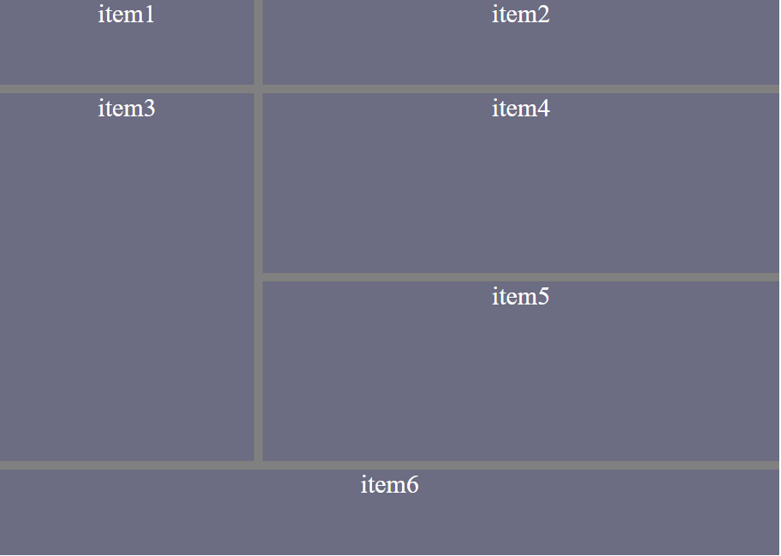
And grid-template-areas :
<div class="item1" style="grid-area: item1">item1</div>
<div class="item2" style="grid-area: item2">item2</div>
<div class="item3" style="grid-area: item3">item3</div>
<div class="item4" style="grid-area: item4">item4</div>
<div class="item5" style="grid-area: item5">item5</div>
<div class="item6" style="grid-area: item6">item6</div>
<div class="item7" style="grid-area: item7">item7</div>
<div class="item8" style="grid-area: item8">item8</div>
<div class="item9" style="grid-area: item9">item9</div>
CSS:
.container {
background: gray;
display: grid;
grid-auto-rows: minmax(100px, auto);
gap: 10px;
grid-template-areas: "item9 item9 item9" ". . ." ". . ." "item1 item2 item3" "item4 item5 item6" "item7 . item8 ";
}

.container div {
background: rgba(0, 0, 139, 0.158);
font-size: 30px;
color: white;
text-align: center;
}
You can chooose any property you want based on your needs

Animation
CSS allows animation of HTML elements without using js or flash.
In this chapter you will learn about the following properties :
- @keyframes
- animation-name
- animation-duration
- animation-delay
- animation-iteration-count
- animation-direction
- animation-timing-function
- animation-fill-mode
- animation

What are CSS Animations?
An animation lets an element gradually change from one style to another.
You can change as many Css properties you want, as many times you want.
To use CSS animation, you must first specify some keyframes for the animation.
Keyframes hold what styles the eleement will have at ceratin times.

The @Keyframes Rule :
When you specify CSS Styles inside the @keyframes rule, the animation will gradually change from the curenet style to the new dtyle at certain times.
To get an animaton to work, you must bind the animation to an element.
div {
width: 150px;
height: 150px;
animation: color 5s;
position: absolute;
}

@keyframes color {
from {
background-color: red;
left: 100px;
}
to {
background: dodgerblue;
left: 500px;
}
}

Note : The animation-duration property defines how long an animation should take to complete. If the animation-duration property is not specified, no animation will occur, because the default value is 0s
In the example above we have specified when the style will change by using the keywords "from" and "to" (which represents 0% (start) and 100% (complete)).
It is also possible to use percent. By using percent, you can add as many style changes as you like.
The animation-delay property specifies a delay for the start of an animation.
Negative values are also allowed. If using negative values, the animatin will start as if it had already been playing for N seconds.
The animation-iteration-count property specifies the number of times an animation should run.
Use the value of “infinite” to make the animatin continue for ever.
The animation-direction property specifies whether an animaton should be played forwards, backwards or in alternate cycles.
The animation-direction property can have the following values :
- normal - The animation is played as normal (forwards). This is default
- reverse - The animation is played in reverse direction (backwards)
- alternate - The animation is played forwards first, then backwards
- alternate-reverse - The animation is played backwards first, then forwards
The animation-timing-function property specify the speed curve of the animation.
The animation-timing-function property can have the following values :
- ease - Specifies an animation with a slow start, then fast, then end slowly (this is default)
- linear - Specifies an animation with the same speed from start to end
- ease-in - Specifies an animation with a slow start
- ease-out - Specifies an animation with a slow end
- ease-in-out - Specifies an animation with a slow start and end
- cubic-bezier(n,n,n,n) - Lets you define your own values in a cubic-bezier function, you can use cubic-bezier.com to generate one for you
CSS animation do not affect an element style before first frame or last frame is excuted, but animation-fill-mode broke this .
The animation-fill-mode property specify a style for the target element when the animation is not playing.
The animation-fill-mode property can have the following values :
- none - Default value. Animation will not apply any styles to the element before or after it is executing
- forwards - The element will save the style values that is set by the last keyframe (depends on animation-direction and animation-iteration-count)
- backwards - The element will get the style values that is set by the first keyframe (depends on animation-direction), and saves this during the animation-delay period
- both - The animation will follow the rules for both forwards and backwards, extending the animation properties in both directions
The animation-play-state : specifies whether the animation is running or paused
The animation : is a shorthand for setting all the animation properties.

Transition
CSS Transition allows you to change property values smothly

CSS Transition Methods :
Transition : is a shorthand for setting all the four propeties in a single property.
Transition-property: specify the name of property that transition will affect.
Transition-duration : specify the duration that an animation should takes.
Transition-delay : specify the delay for the animation.
Transition-timing-function : specify the speed of an animation.
Note : setting transition-duration is required because default value is 0, so the transition won’t have any effect.

Transform

2d transformation
CSS Transform allow you to rotate, translate, skew, scale an element .
# rotate : property allow to rotate an element clockwise or counter-clockwise by a given value
Note : negative value will make a counter-clockwise rotation.
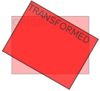transform: rotate(20deg);

# translate : property move an element vartically and horizantally.
transform: translate(100px, 50px);
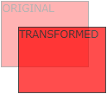
the element move 50px to right and 100px to bottom
# scale : property increase or decrease the size of an element, it multipe the width or height of element but prameter values :
transform: scale(2, 1.2);

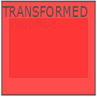
Note : scale is a shorthand for scaleX and scaleY.

# skew : property skew an element from x-axis and y-axis by the given anlge. Make in mind if you give the property one value so it will work for x-axis only.
Skew is a shorthand for skewX and skewY
transform: skew(20deg, 20deg);

# Matrix : property combines all 2d transform methods into one .
The parameters are as follow : scaleX() skewY() skewX() scaleY() translateX() translateY()
transform: matrix(1.2, 0.2, 0.5, 1.8, 100, 50);
Note : is very important to note that the parameters is delcared without their units

3d Transformation
CSS support also 3d transformation.
It a little bit as 2d transformation but with Z-axe.
But Before that, you have some essential
# Perspective : property used to give a 3d-positioned element.
It specifies how far an element is away form the user . so smaller value will give more intesitive 3d effect than the higher values.
When we defined the prespective property for an element, it is child element who the perspecitve view and, Not the element its self.

# Perspective-origin : property defines at from which prositon the user is looking at the 3d-positionned element.
When you define a property for an element, it child that will get the effect, and NOT the element it self.
Perpective-origin must be used in conjunction اِقتِران with perspective .
Syntax : perspective-orign : x-axis , y-axis.
Possible values for each param :
- X-axis : left, center, right , length, %
- Y-axis : top , center, bottom, length , %
# transform-origin : propery specify the point where the transformation is done.
In 2d transformation x-axis and y-axis , but in 3d transformation we have also z-axis.
Possible values for each param :
- X-axis : left, center, right , length, %
- Y-axis : top , center, bottom, length , %
- Z-axis : length
# transform-style : propery specify how nested elements are rendered in the space.
Transform-style has 2 possible values : flat, preserve-3d
Flat : nested element will not preserve their 3d positon, so the element will be flat.
Preserve-3d : nested element will preserve their 3d positon .
# backface-visibility property defines whether or not the back face of an element should be visible when facing user.
body {
background: rgba(128, 128, 128, 0.342);
}
.center {
display: flex;
justify-content: center;
align-items: center;
}
.container {
width: 300px;
height: 500px;
transition: 2s transform;
color: #fff;
font-size: 50px;
position: relative;
transform-style: preserve-3d;
}
.container div {
backface-visibility: hidden;
transform-style: preserve-3d;
perspective: 1000px;
}
.container div p {
transform: translateZ(50px);
padding: 10px;
box-shadow: -1px 8px 14px 0px white;
}
.container div:nth-child(2) {
background: darkblue;
}
.container div:first-child {
background: yellowgreen;
}
.container div {
position: absolute;
width: 100%;
height: 100%;
}
.container:hover,
.container div:nth-child(2) {
transform: rotateY(180deg);
}

HTML :
<div class="container">
<div class="center"><p>First Face</p></div>
<div class="center"><p>Second Face</p></div>
</div>

